Waerenga Wallaby Poisoning Operation

What’s happening?
Contractors working for the Bay of Plenty Regional Council will be carrying out a poisoning operation, targeting wallabies, over parts of the Waerenga, Pukahukiwi-Kaokaoroa, Te Karaka and Wairarapa-Moana land blocks, north of Lake Rotorua between Hamurana and Ōkere Falls. The operational area will cover a mix of native and exotic forest, totaling 670ha.
This operation will use Pindone cereal baits and Feratox encapsulated cyanide in Philproof bait stations (a white plastic box) attached to wooden stakes at approximately 100 metre intervals.

When?
Work will start on or after 27 June 2022 and carry on into July, August and September.

Why is this work important?
Wallabies eat seedlings, grass and crops, causing costly losses to forestry and farming. In native forest they can have a dramatic impact on the understory, targeting some species which over time will alter species diversity.
Since Dama wallabies were first released near Lake Okareka in 1912, they have spread to occupy over 200,000 ha, across the Bay of Plenty and parts of the Waikato region.
The Kaituna (Okere) River is an effective barrier to wallaby dispersal, and it forms the northwestern boundary of the Wallaby Containment Area. Very few wallabies occur west of the river. For this reason, eradicating wallabies from the Waerenga operational area (which is outside of the Wallaby Containment Area) is a high priority.

How will this operation affect you?
The operational area is entirely on private land, so access to this area can only be gained with permission of the landowners, forest managers and farm staff.
Poison warning signs will be placed at all of the normal access points to the operational area.
Hunters are advised not to take animals for human consumption from within the operational area during the caution period, which will end when the warning signs are removed by the contractor.

For more information, contact:
Dale Williams, Biosecurity Officer, Bay of Plenty Regional Council 0800 884 880 dale.williams@boprc.govt.nz

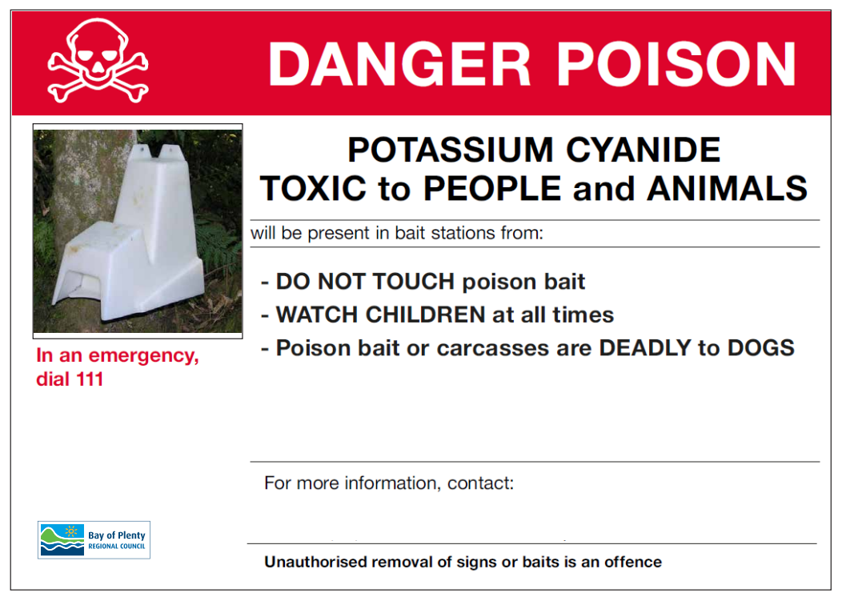

Waerenga Wallaby Poisoning Operational Area

