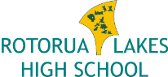

‘Mauria te Pono - Keep steadfastly to the truth’

SCHOOL BUS ANNOUNCEMENT

We are delighted to announce that Rotorua Lakes High School will be running a bus from Kaharoa Primary School to Rotorua Lakes High School in 2021. For further information please contact humphriesj@rototrualakes.school.nz

If you wish to come and look around RLHS please give us a call 07-3456124

Nga Mihi

Jon Ward
Principal
Lakes High School

