Dear Parents/Caregivers,

Lakes Performing Arts Company is able to offer some Dance and Drama exam classes at Kaharoa School during school lunchtimes. Dance exams are in September, and there is the option to offer Trinity Speech and Drama Examinations too. We have three options available, Jazz, Hip Hop dance or Drama classes. This is perfect for those busy families who can not always get their child to these after school activities. Each class would involve 1-hour tuition per week at Monday lunchtimes, and an enrolment form would need to be completed.

Please see the costs below which is required in advance at the beginning of each term:
Drama $142.00 Per Term - Grade Class
Hip Hop Dance $132.00 Per Term – Grade Class
Jazz Dance $132.00 Per Term – Grade Class

There will be an additional charge for exam fees if students wish to sit the examinations:
Drama – between $135 - $190 depending on age
Dance – between $60 - $80 depending on age
All payments are to be made directly to Lakes Performing Arts Company.

This is open to all students and if we receive a high interest, we can create more classes for the students. If you are interested, please complete the below form with all details and return the slip to the school office.

Thank you,
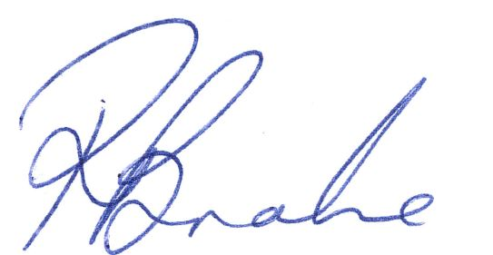

Rebecca Brake
Managing Director
Lakes Performing Arts Company

Please tick which box applies and return this slip to the office.
---------------------------------------------------------------------------------------------------------------------------
Yes my child is interested in the following classes:
Child’s Name: | Child’s Room Number: | Hip Hop Dance
 | Child’s Age:
Parents/Caregivers Name: | Contact Number: | Jazz Dance
Contact Email: |  | Drama

