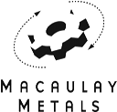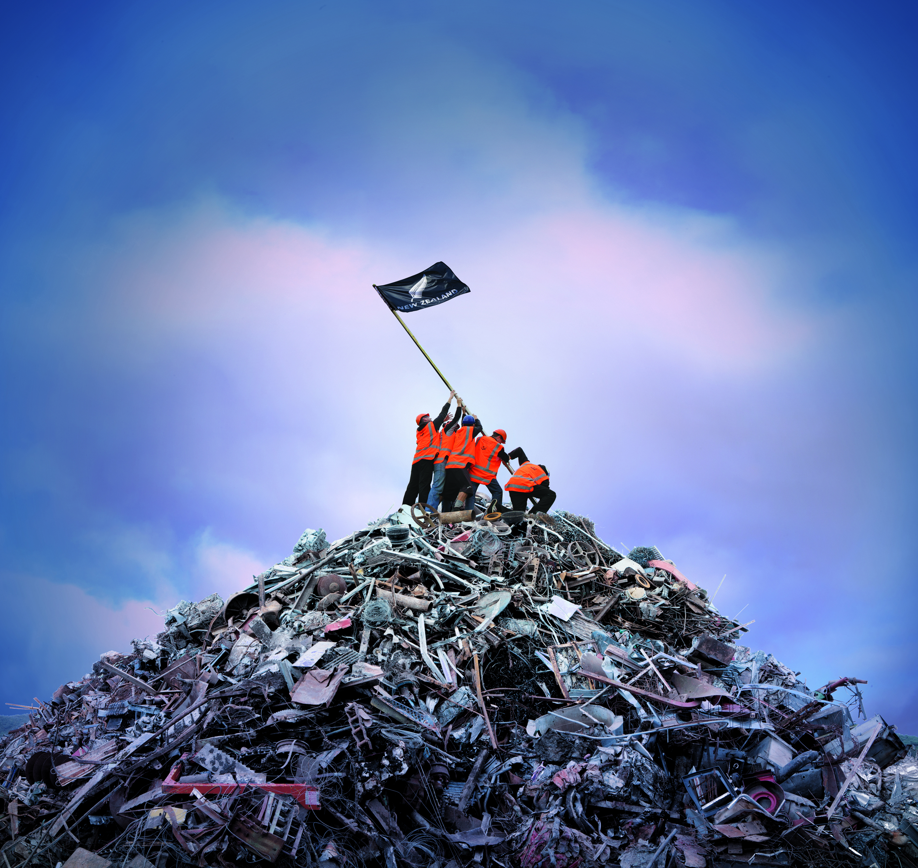

All proceeds going to KAHAROA SCHOOL (07)332 3444

**What is accepted?**

Aluminium; Brass; Cans; Car Batteries; Cast Iron; Copper; Electrical Cable; Electric Motors; Lead; Steel; Stainless Steel; Cars; Washing Machines; Ovens; Fridges; Freezers - METAL

**What is not wanted?**

Tyres; Lithium Ion Batteries; Plastic; Wood; Household Waste; Glass

Help Macaulay Metals build a mountain of scrap for Kaharoa School on Gypsy Day

**Scrap Metal Drive: 1st June – 3rd June 2019**

**Drop off: Kaharoa School – Follow the Signs**